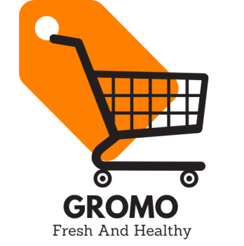

**GROM**

**Grocery website**

## Gromo is a website which helps the people to get the best, fresh, and Hygienic products of the Groceries to fulfill their daily essential requirements.

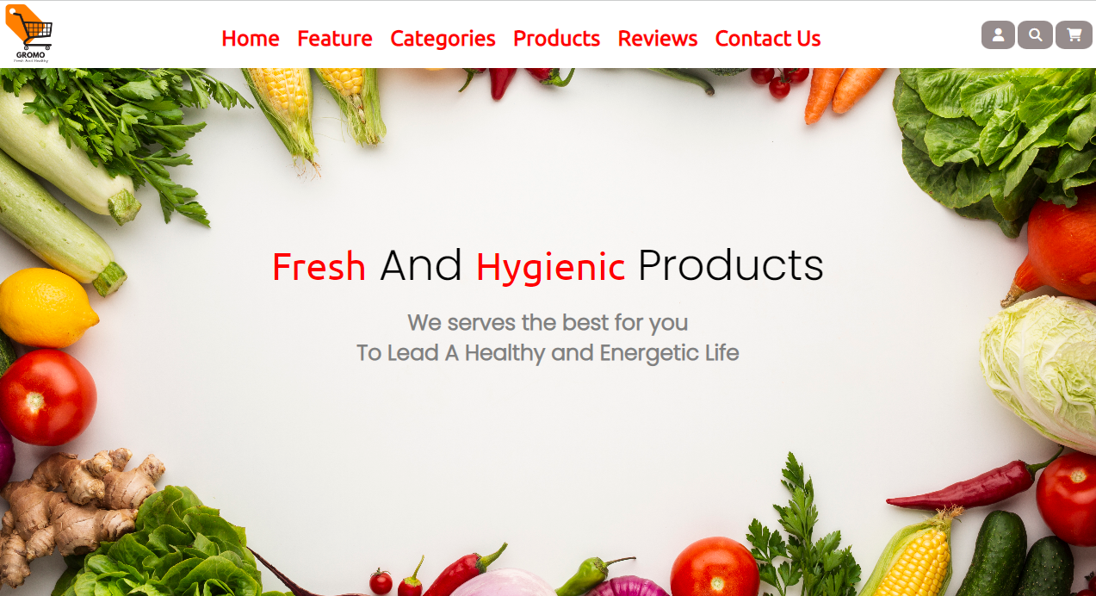

About Gromo website

* Structure of the Gromo website:
* In the **Navigation bar**, it includes the logo of the website at the left-top corner. In the middle all the page location button. And at the right-top corner Login/signup, Cart, Search bar.
* It consist of basically (Home, Features, Products, Categories, Reviews, Contact us) sections.
* It is also fully Responsive.
* It works dynamically to take the input from the user and gives the desired response.
* It provides online order facility, sorting and so on.
* **Feature section**:
* In the feature section user can come to know about what kind of facilities we were offering them.
* **Categories section**:
* In the Categories section user can enlist the food categories.
* **Product section**:
* In the Product section user can access all the available products.
* **Reviews section**:
* In the Reviews section user can see the other customer reviews.
* **Contact section**:
* In the Contact section user can keep in touch with us if any query.
* **Footer section:**
* In the footer section user can get all reference links, social media links.